

# 

# Cases

**CFEH**

**CFEH Facebook Case #152**

A 70 year old Asian female presented for examination. She reports a history of trachoma that was treated with a membrane peel many years ago. The photo below shows extensive follicles which are characteristic of this condition (more easily appreciated with fluorescein staining). There are also concretions present which are unlikely to be related to the trachoma. For more information on trachoma, please click here.

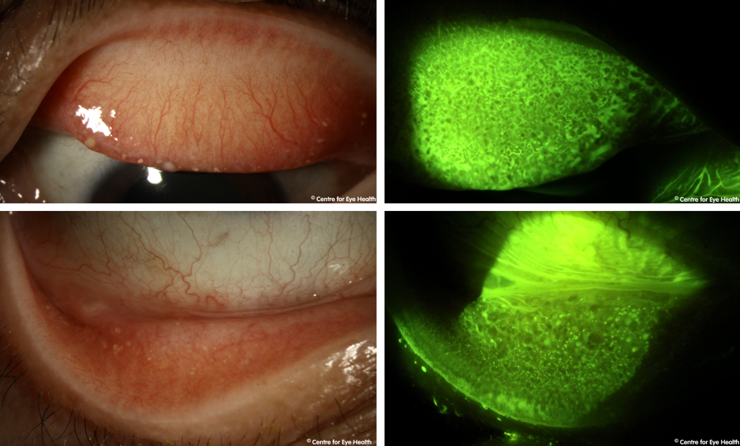





**Answer**

Trachoma is a bacterial infection caused by *Chlamydia trachomatis*. It is typically associated with poor hygiene and/or poverty and is easily spread through direct or indirect contact with infected eye secretions. If left untreated, trachoma can cause blindness with chronic, recurrent inflammation causing scarring of the palpebral conjunctiva which leads to entropian, trichiasis and corneal scarring.

Although improved hygiene has seen the eradication of this disease in many countries of the world, it is still found in more than 50 developing countries throughout Africa and Asia. Australia is the only developed country where this condition may still be seen – typically in remote outback communities. Progress is being made towards the eradication of this disease in Australia, a goal expected to be met in the near future.

Infection starts with conjunctivitis and lid oedema due to inflammation. Early signs of infection include the presence of lid follicles and papillae which undergo progressive hypertrophy. Corneal pannus starts to develop (the growth of blood vessels past the limbus and into the cornea). Over time symblephron form, lids become entropic and the resulting trichiasis causes corneal scarring and vision impairment.